INFORMATION MANAGEMENT

EXERCISE 4

1. List the first and last names of all employees who draw less than or equal to 95000 and are programmers, Senior programmers or Multimedia programmers.

SELECT f_name, l_name FROM employee_data

WHERE salary <= 95000

AND (title = 'Programmer' OR title = 'Senior Programmer' OR title = 'Multimedia Programmer');

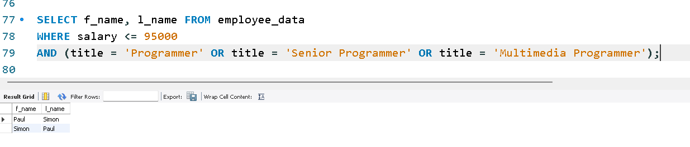

2. What is displayed by the following statement?

SELECT f_name, l_name FROM employee_data WHERE title NOT LIKE '%Marketing%' AND age < 30;

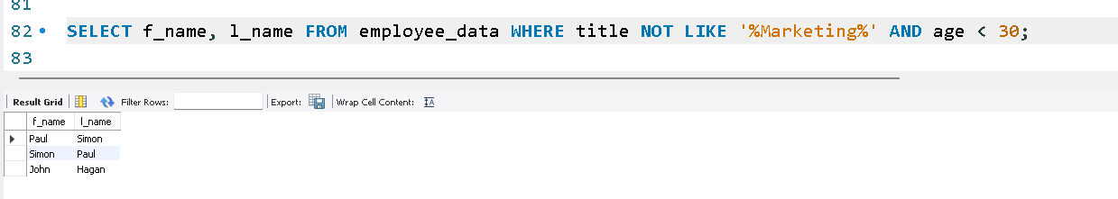

3. List all ids and names of all employees between 32 and 40 years of age.

SELECT emp_id, f_name, l_name FROM employee_data WHERE age BETWEEN 32 AND 40;

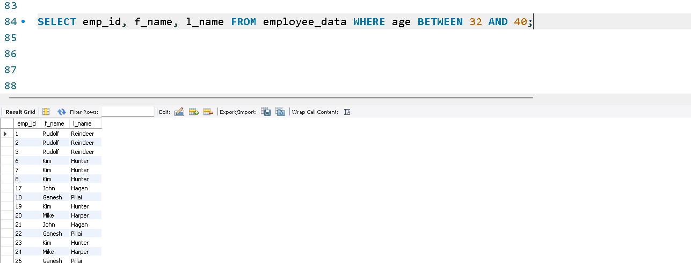

4. Select names of all employees who are 32 years of age and are not programmers.

SELECT f_name, l_name FROM employee_data

WHERE age = 32 AND title NOT LIKE '%Programmer%';

